**Project Name:** Addressing Water and Sanitation Disparities in Kenya

**Part 1: SDG Selection and Problem Definition**

SDG 6: Ensure availability and sustainable management of water and sanitation for all.

**Problem:** Disparities in access to clean water and adequate sanitation in Kenya, leading to health issues and hindering socio-economic development.

**Part 2: Database Design (ERD Diagram)**

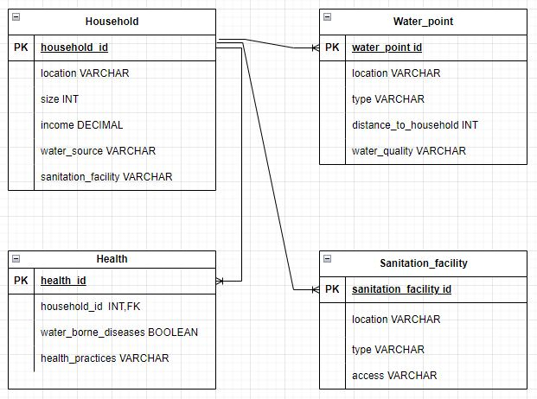

**SQL statements to create database schema**

CREATE TABLE Household (

household_id INT PRIMARY KEY,

location VARCHAR(100),

size INT,

income DECIMAL(10,2),

water_source VARCHAR(50),

sanitation_facility VARCHAR(50)

);

CREATE TABLE Water_point (

water_point_id INT PRIMARY KEY,

location VARCHAR(100),

type VARCHAR(50),

distance_to_household INT,

water_quality VARCHAR(50)

);

CREATE TABLE Sanitation_facility (

sanitation_facility_id INT PRIMARY KEY,

location VARCHAR(100),

type VARCHAR(50),

access VARCHAR(50)

);

CREATE TABLE Health (

health_id INT PRIMARY KEY,

household_id INT,

waterborne_diseases BOOLEAN,

hygiene_practices VARCHAR(255),

FOREIGN KEY (household_id) REFERENCES Household(household_id)

);

**Populating data to the database**

**Household table**

INSERT INTO household (household_id, location, size, income, water_source, sanitation_facility)

VALUES

(1, 'Nairobi', 5, 30000, 'Tap Water', 'Flush Toilet'),

(2, 'Mombasa', 3, 15000, 'Borehole', 'Pit Latrine'),

(3, 'Kisumu', 8, 25000, 'Lake', 'None'),

(4, 'Nakuru', 6, 28000, 'Borehole', 'Pit Latrine'),

(5, 'Eldoret', 4, 35000, 'Tap Water', 'Flush Toilet'),

(6, 'Kisumu', 7, 22000, 'Lake', 'None'),

(7, 'Mombasa', 5, 18000, 'Borehole', 'Pit Latrine'),

(8, 'Nairobi', 3, 40000, 'Tap Water', 'Flush Toilet'),

(9, 'Malindi', 2, 16000, 'Rainwater', 'Pit Latrine'),

(10, 'Nyeri', 8, 29000, 'Spring', 'Flush Toilet');

**Water_point table**

INSERT INTO water_point (water_point_id, location, type, distance_to_household, water_quality)

VALUES

(1, 'Nairobi', 'Public Tap', 500, 'Clean'),

(2, 'Mombasa', 'Borehole', 200, 'Slightly Salty'),

(3, 'Kisumu', 'Lake', 100, 'Contaminated'),

(4, 'Nakuru', 'Public Tap', 600, 'Clean'),

(5, 'Eldoret', 'Borehole', 300, 'Slightly Salty'),

(6, 'Kisumu', 'Lake', 150, 'Contaminated'),

(7, 'Mombasa', 'Borehole', 250, 'Slightly Salty'),

(8, 'Nairobi', 'Public Tap', 400, 'Clean'),

(9, 'Malindi', 'Rainwater', 800, 'Salty'),

(10, 'Nyeri', 'Spring', 700, 'Clean');

**Sanitation facility table**

INSERT INTO sanitation_facility (sanitation_facility_id, location, type, access)

VALUES

(1, 'Nairobi', 'Flush Toilet', 'Public'),

(2, 'Mombasa', 'Pit Latrine', 'Private'),

(3, 'Kisumu', 'None', 'None'),

(4, 'Nakuru', 'Pit Latrine', 'Private'),

(5, 'Eldoret', 'Flush Toilet', 'Public'),

(6, 'Kisumu', 'None', 'None'),

(7, 'Mombasa', 'Pit Latrine', 'Private'),

(8, 'Nairobi', 'Flush Toilet', 'Public'),

(9, 'Malindi', 'Pit Latrine', 'Private'),

(10, 'Nyeri', 'Flush Toilet', 'Public');

**Health table**

INSERT INTO health (health_id, household_id, waterborne_diseases, hygiene_practices)

VALUES

(1, 1, FALSE, 'Good'),

(2, 2, TRUE, 'Fair'),

(3, 3, TRUE, 'Poor'),

(4, 4, TRUE, 'Fair'),

(5, 5, FALSE, 'Good'),

(6, 6, TRUE, 'Poor'),

(7, 7, FALSE, 'Fair'),

(8, 8, FALSE, 'Good'),

(9, 9, TRUE, 'Poor'),

(10, 10, FALSE, 'Good');

***Part 3: SQL Programming***

*Data Retrieval;*

**Count of households by water source**

SELECT water_source, COUNT(*) AS number_of_households

FROM Household

GROUP BY water_source;

**Select all households with access to clean water.**

SELECT COUNT(*) AS households_with_clean_water

FROM Household h

INNER JOIN Water_point w ON h.location = w.location

WHERE w.water_quality = 'Clean';

**Number of households with waterborne diseases**

SELECT COUNT(*) AS households_with_waterborne_diseases

FROM Health

WHERE waterborne_diseases = TRUE;

**Correlation between water source and waterborne diseases**

SELECT h.water_source, AVG(s.waterborne_diseases) AS average_waterborne_diseases

FROM Household h

INNER JOIN Health s ON h.household_id = s.household_id

GROUP BY h.water_source;

Data Analysis Examples:

Calculate average distance to water points by region.

SELECT h.location, AVG(w.distance_to_household) AS average_distance

FROM Household h

INNER JOIN Water_point w ON h.location = w.location

GROUP BY h.location;

**Identify hotspots with high rates of waterborne diseases.**

SELECT h.location, AVG(s.waterborne_diseases) AS waterborne_disease_rate

FROM Household h

INNER JOIN Health s ON h.household_id = s.household_id

GROUP BY h.location

ORDER BY waterborne_disease_rate DESC;